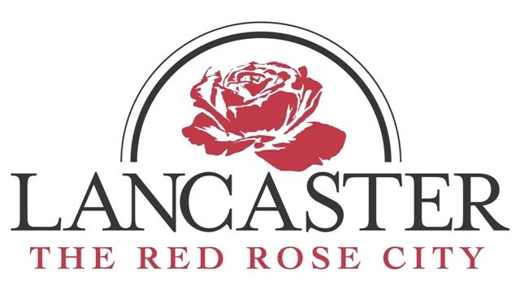
AGENDA
CITY OF LANCASTER
PUBLIC WORKS, PUBLIC UTILITIES AND SOLID WASTE
STANDING COMMITTEE MEETING

THURSDAY, NOVEMBER 2, 2017, 12:00PM
SOLID WASTE CONFERENCE ROOM
1309 LYNWOOD DRIVE

- Invocation – Mayor John Howard

- Approval of Minutes
Standing Committee Meeting – June 7, 2017 – Minutes will be provided at next meeting with minutes from today’s meeting

- Public Utilities – Ledford
- Lower Catawba River Discharge Group Update
- Solar Array Proposal
- Sludge Press End of Life

- Public Works – Crockett
  - Upcoming Changes with MXU Boxes
  - Chester County Wastewater Recovery Increase Sewer Flow Request

- Solid Waste - Cauthen
- Transfer Station Conditions and Expansion
- Warehouse Attendant
- Maintenance of City Parks

Any person requiring special accommodations should contact the Office of the City Administrator at (803) 286-8414 at least 24 hours prior to the scheduled meeting.

