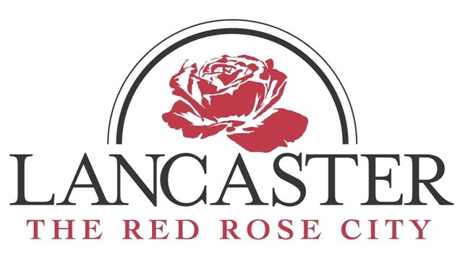
AGENDA
CITY OF LANCASTER
PUBLIC WORKS, PUBLIC UTILITIES AND SOLID WASTE
STANDING COMMITTEE MEETING

WEDNESDAY, NOVEMBER 7 2018, 12:00PM
SOLID WASTE CONFERENCE ROOM
1309 LYNWOOD DRIVE

- Invocation

- Approval of Minutes
  - Standing Committee Meeting – June 7, 2017
  - Standing Committee Meeting – November 2, 2017

- Public Utilities – Ledford
  - Public Utilities Sludge Dewatering Press Update
  - Update on Current Issues

- Solid Waste - Cauthen
  - Recycle Proposal
  - Equipment

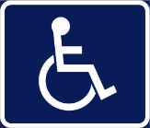
Any person requiring special accommodations should contact the Office of the City Administrator at (803) 286-8414 at least 24 hours prior to the scheduled meeting.

