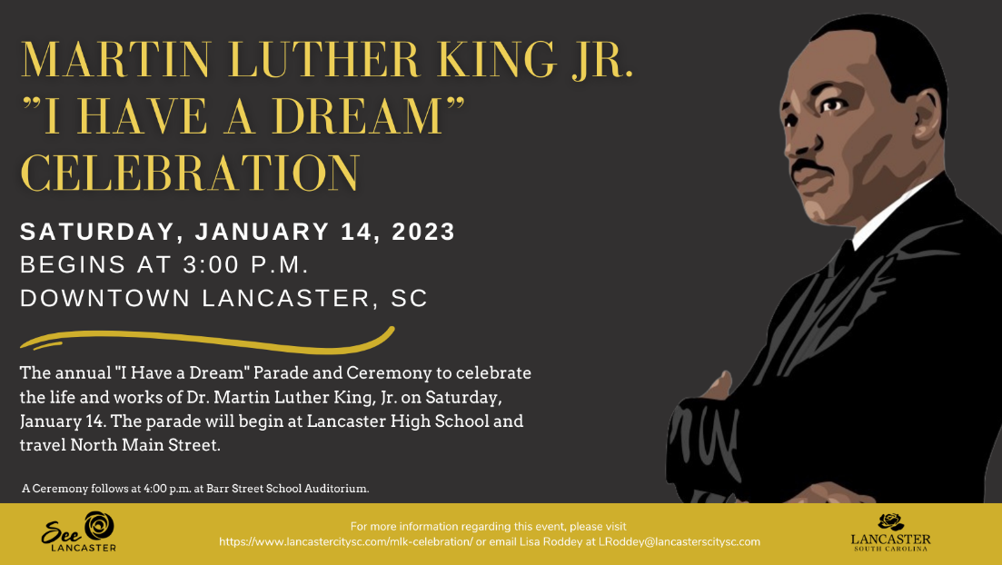

Please read all pages and fill out page 3 and page 4.

PARADE & CEREMONY
Historic Downtown Lancaster
The parade committee cordially invites you to participate in the “I Have A Dream” parade honoring the life and legacy of Dr. Martin Luther King, Jr. on January 14, 2023 at 3 pm with ceremony to follow in Barr Street Auditorium.

The application deadline is January 6, 2023, by 5 PM. Please submit your application with required attachments by this date, and $10 application fee. Placement in the parade is based upon application submission and type of entry.

The Parade and Ceremony are based on Dr. Martin Luther King, Jr.’s public speech on August 28th, 1963, in which he called for an end to racism in the United States. This speech was delivered to over 250,000 civil rights supporters from the steps of the Lincoln Memorial. We ask that all entries decorate their unit to reflect the theme of the parade through music, decoration or dance.

The parade route will start at Lancaster High School Parking Lot and end at Williams St. Application deadline is January 6, 2023 at 5 PM, entry numbers will be emailed the week of the parade. All Details for vehicles must be on the application no other added vehicles will be added unless you contact events@lancastercitysc.com or lroddey@lancastercitysc.com.

Following the parade, please join us in the Barr Street Auditorium (610 E Meeting Street Lancaster SC 29720) for an inspirational ceremony and winners of the “I Have a Dream” essay contest. Parking will be available. Please use front parking, handicap parking will be closest to the back entrance.
Please call or e-mail with any questions or concerns that you may have! We look forward to seeing you on Saturday, January 14th!

Lisa Roddey
DATES TO REMEMBER:
DEADLINE January 6th by 5 pm: Parade Application Due in office of See Lancaster, with $10 fee
Entry Numbers and Line-Up placed on city web site www.lancastercitysc.com
Events and Promotions Manager City of Lancaster
201 W. Gay St.
Lancaster, SC 29720 lroddey@lancastercitysc.com

“I Have a Dream” Parade
Saturday, January 14, 2023 ~ 1 pm ~ Guidelines and Rules
Application Deadline January 6, 2023 by 5 PM
Entries participating in this theme will be eligible for judging. It is very important to the success of the parade and the full enjoyment and safety of all participants and spectators that you know your responsibilities. Please review these guidelines with your participants.

Parade Units:
  - STAGING begins at 1:30 pm and ends at 2:30 pm on Jan. 14, Location Lancaster High School. No admittance after 2:15 pm.
  - NO THROWING OF GUM, CANDY, AND/OR OTHER MATERIALS from units.
  - Walkers may hand out candy.
  - Alcoholic beverages are forbidden
  - No smoking on or around units
  - FLOATS: Higher than 30 inches from the ground must have side rails. Rails should measure a minimum of three feet from the floor of the unit.
  - Participants are not allowed on or off of the parade unit once in motion.
  - All motorized units must be operated by a licensed driver with current auto insurance. ALL PARTICIPANTS MUST PRESENT DRIVERS LICENSE AND INSURANCE (General Automotive Insurance) AT STEP- OFF
  - Only street legal vehicles are allowed with general liability insurance shown at line up. If insurance is not present, you will be asked to leave the lineup. Horses/ Horse Groups must have Equine general liability insurance coverage and proof at the parade.
  - Motorcycles/Automobiles/Horses/Any parade applicants that do any of the following (but not limited to): “racing”, “figure eights,” “Wheelies,” or anything considered “stunting” or “reckless behavior” will be ticketed or banned from participating in future events with the City of Lancaster.
  - Motorcycles will be idling frequently.

All Parade Entries:
  - ALL PERFORMANCE groups are limited to 20 second performances. You may perform a one-minute performance at the Learn TV Area.
  - All performances must be in good taste. This is a family event, therefore routines and or expressions that are lewd, obscene are expressly prohibited and likewise actions portraying violent, abusive and/or offensive behavior are not permitted and will be grounds for removal.
  - Adult 18 years or older must accompany children at all times.
  - The signing applicant must have rules in their possession and be present at time of entry inspection.

Entry Numbers/Signage
  - Entry Numbers, will be provided by the City of Lancaster Parade staff and distributed during parade line-up.
  - Signage: Participants are responsible for sign or placard stating the name of the entry and sponsor. Signs must be on the first vehicle or held by the person at the front on the LEFT.
  - PARADE JUDGING: BEST SOUND, MOST SPIRIT. MOST CREATIVE, BEST BAND, BEST STEP
- NO On-Day Parade REGISTRATIONS. No Added Vehicles the day of.
  - SAFETY IS FIRST! We also reserve the right to remove any entry or participant from the parade when the actions of that entry, or its participants, present a danger to spectators or other parade entries. Decisions of The City of Lancaster and Parade Committee are final. If any automobiles, motorcycles, horses, or Any parade applicants that do any of the following (but not limited to): “racing”, “figure eights,” “Wheelies,” or anything considered “stunting” or “reckless behavior” will be ticketed or banned from participating in future events with the City of Lancaster.
The primary focus of the “I Have a Dream” Parade is to provide a safe, enjoyable and quality parade in and on the streets of Downtown Lancaster in celebration of the life and Legacy of Martin Luther King, Jr. If at anytime leading up to or on parade day the weather/street conditions are deemed unsafe, the parade will be cancelled and rescheduled per Lancaster City.

2022 Martin Luther King, Jr. Parade

“I Have a Dream” Parade
Saturday, January 14, 2023 ~ 3:00 pm
Organization Contact Person Address City State
Zip Phone: Primary Secondary
*****E-mail: (Communication will be through e-mail unless otherwise noted)

ENTRY TYPE: Please complete all entry information… Each form represents ONE entry

Vehicles must be written down and no add on vehicles the day of.
- Professional Floats: (Floats are delivered and driven by Cline Floats Co. Please call events office for available rentals and information: 803-286-1489 or contact Cline Floats directly at 828-241-3133).
  - With Walking Group? YES NO
- Self-Built Float: (1 Float) Truck plus trailer. No extra cars if so that is self-built and motorized.
  - With Walking Group? YES NO
  - Make/Model of vehicle pulling float
  - Type of trailer used as the float and size

Overall length and full measurements are important for positioning in staging area
- Motorized Unit: (up to 2 motorized units ONLY) Both Vehicles must be written down.
  - Make/Model of vehicle(s)

With Walking Group? YES NO
- Walking Unit: No Vehicle
  - Type of Walking Group (stepping group, marching band, Church group) etc.
- WILL Music/Sound be added? yes no.
  - If yes, in what way… singing, sound system, Please explain

ENTRY FEE: $10
Return this entry form and appropriate entry fee by January 6, 2023. Mail to “I have A Dream Parade” PO Box 1149, Lancaster, SC 29721

INDEMNITY AND HOLD HARMLESS AGREEMENT
I/we further agree to defend, and hold harmless the City of Lancaster, SC, The I Have a Dream parade committee and its employees or agents against loss or expense, including attorney’s fees for loss or expense because of bodily injury, death or property damage sustained by any person or persons arising from, connected with, or caused by the negligent acts or omissions of the participant, its agents, officers, or employees. It is further agreed that I/we, as participants, will provide proof of general liability and auto insurance for the parade entry naming the City as an additional insured.
Participant further agrees to have received, read, understood, and will fully comply with all of the City of Lancaster “I Have A Dream” parade Rules and Regulations.

Name of Organization Organization Representative

Date:

EMAIL:

Participant’s Signature Participant’s Parent or Guardian

REQUIRED 2022 MLK, Jr. Parade Unit Information
Please complete for our hosts to use on the parade. Use additional pages if necessary
Name: Contact Information: Email:

What does your vehicle or float look like?

Person in charge of organization:

Number of members in your organization:
When your organization was founded:

When your organization meets/number of hours it practices OR if business, hours of operation.

Your activities during the year or services you provide:

Any unusual stories about building the float or about your organization that you want to share:

Other information you would like us to share on TV:

